QUESTION 1 Notes

Question 1 A
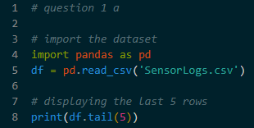
- Action – Using pd.read_csv() to load the file
- Using df.tail(5) to display the final five rows. This is to ensure the data has loaded correctly from beginning to end and to see the column names (ReadingID, PollutantLevel, AreaCode)

Question 1 B
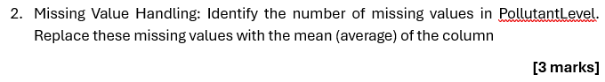
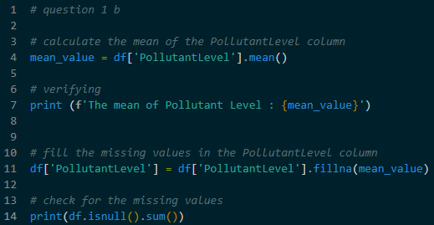
- Calculating the mean for the specific column, to fill in the empty cells
- Using .fillna() to put the mean value into every empty cell. This prevents errors in later steps

Question 1 C
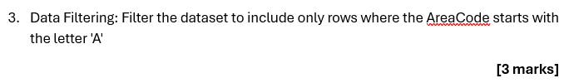
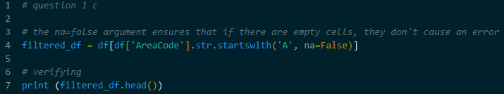
- Using .str.startswith(‘A’) to look for every row where the AreaCode starts with the letter ‘A’
- A new, smaller table is created that contains only the information for the ‘A’ areas

Question 1 D
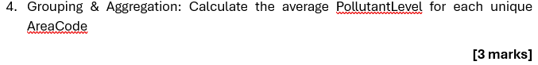
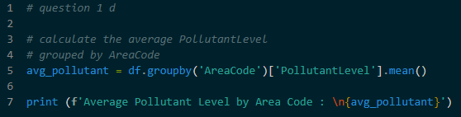
- Grouping the data by AreaCode to put all identical area codes into one set
- Calculating the average PollutantLevel for each of these sets
- This tells which area has the highest or lowest pollution on average, rather than looking at individual readings

Question 1 E
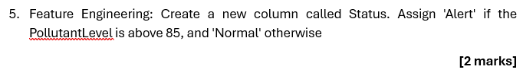
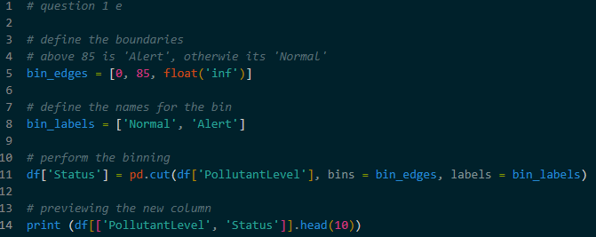
- Setting a limit(85). If the value is above 85, it is labeled ‘Alert’. If it is 85 or below, it is labeled ‘Normal’
- Using pd.cut() – This function takes the numerical data and sorts it into bins (categories) based on the limits defined
- A new column named Status is added to the table

Question 1 F
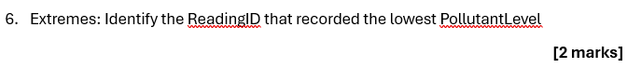
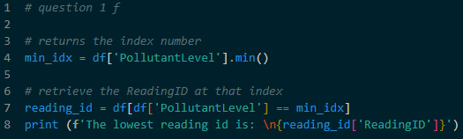
- Looking for the minimum value in the PollutantLevel column using .min()
- Once the lowest number is found, it find the row It belongs to and print the ReadingID
- Using idxmin() or conditional filtering (df[df[‘PollutantLevel’] == min_value]) to get the exact ID for the specific record

